One Piece Character Classification with ResNet18

Goal:
The goal of this project is to train a model to classify images of 18 One Piece characters.
The project includes data preparation, model training using a pretrained ResNet18, and evaluation on
test data. Special attention is given to analyzing model errors and understanding its limitations.

Dataset:
The dataset consists of 18 classes, each representing a different One Piece character.
Each class contains approximately 650 images.
Around 215 images per class are original, while the rest are generated from them using simple
transformations such as color inversion and rotations. In some class, the number of original images is
slightly lower (~140), which introduces minor imbalance.
Images derived from the same original form small groups of visually related samples. This was taken into
account during dataset splitting in order to reduce data leakage between training and evaluation sets.
These transformations increase dataset diversity but also make the classification task more challenging, as
the model must handle variations that differ significantly from natural images. Example:
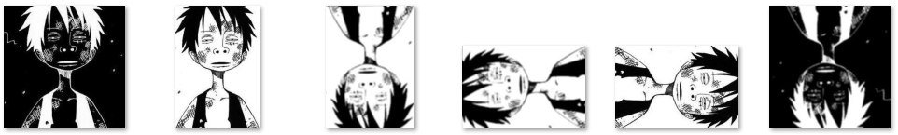

Data Split:
The dataset was divided into training, validation, and test sets.
The split was performed in two steps. First, 10% of the data was reserved for the test set. Then,
10% of the remaining data was used for validation, with the rest used for training.
Instead of a fully random split, images derived from the same original (e.g., rotated or color-inverted
versions) were grouped together and assigned to the same subset.
This approach helps reduce data leakage, ensuring that the model is evaluated on truly unseen data rather
than variations of images it has already seen during training.

Model:
A pretrained ResNet18 model was used.
Pretrained models help achieve better results on smaller datasets, as they already learn general image
features.
ResNet18 was chosen because it is relatively simple and efficient, while still providing good performance.
The final classification layer was replaced to match the number of classes (18).

Training / Fine-tuning:
The model was trained using transfer learning.
Initially, most of the pretrained layers were frozen, and only the final classification layer was trained. This
allows the model to adapt to the new task without destroying already learned features.
After that, some deeper layers (e.g., layer4 and later layer3) were unfrozen and fine-tuned to improve
performance.
Training was performed for multiple epochs using mini-batches. A learning rate schedule was used to
gradually reduce the learning rate during training.
Different batch sizes and training configurations were tested to find a stable setup.

Results:
Seed 42 → Test:
Validation Accuracy: 0.9123867069486404
Test Accuracy: 0.9172
Seed 123 → Test:
Validation Accuracy: 0.918429003021148
Test Accuracy: 0.9028
Seed 777 → Test:
Validation Accuracy: 0.9224572004028198
Test Accuracy: 0.9172

The model was trained several times using different random seeds (42, 123, and 777).
The results were similar in all cases, with test accuracy around 0.90–0.92. Small differences are
expected between runs.
For seed = 777, the model achieved about 92% validation accuracy and about 91.7% test accuracy.
This run showed the best validation result among the tested seeds and was selected for further analysis.
Detailed training logs and additional visualizations are provided in the attached files.

Environment:
Language: Python 3.10.11
IDE: Spyder IDE 6.1.3
Framework: PyTorch 2.5.1+cu121
Libraries: OpenCV, NumPy, Matplotlib

Conclusion:
In this project, a model based on ResNet18 was trained to classify images of One Piece characters.
The model reached about 91–92% test accuracy and showed consistent results across different runs.
The project shows that transfer learning is effective even with a relatively small dataset.
At the same time, the model has difficulties with strongly modified images (such as inverted or
rotated ones).
Overall, the model works well, but there is still room for improvement.

